Post 16: Transition Fund Report

Contents

1. Transition Funding Context 2
2. Situation June 2020 2
3. Proposal of work…………………………………………………………………………………………………………………..4
   1. Through Summer/September 4
   2. Our tiered approach 5
   3. Tracking and monitoring 5
4. Outcomes 6

Appendices:

1. Post 16 activity funding spend
2. Contacts made
3. Cohort Review
4. AP Evaluations

## Transition Funding Context

“The AP cohort, a significant proportion of whom are in year 11, are already vulnerable and at greater risk of becoming not in education, employment or training (NEET) than their peers.

These risks have increased since schools closed for most pupils and without substantial transition support, many of the current year 11s in AP are at heightened risk this year of becoming NEET. Becoming NEET limits life chances and engagement in education is a protective factor from a range of harms. Bespoke, needs-based interventions are needed to support these year 11 pupils transition to post-16 provision successfully.”

“This funding is a one-off allocation in response to schools’ limited opening to some pupils due to the coronavirus (COVID-19) outbreak.”

*DfE (2020) ‘Alternative provision: year 11 transition funding*

## Situation June 2020

At the end of June 2020, the government announced additional funding for Year 11 transition support in an attempt to mitigate against the impact that lockdown has had on vulnerable Year 11 students who have finished their secondary education in a PRU or AP. As we had closely tracked our Year 11s through the Lockdown, with the support of Career Connect and The Manchester College, we had 110 pupils with a confirmed offer of a post-16 destinations (*see table below*.). This was in-line with previous years and was above the average for all Year 11s across Manchester, as recorded in the MCC IYSS database.

|  |  |  |
| --- | --- | --- |
| **Destination Status** | **Number of pupils** | **Percentage** |
| Planned | 3 | 2% |
| Applied | 10 | 7% |
| Interview | 2 | 1% |
| Offer | 110 | 72% |
| Tracking towards NEET | 23 | 15% |
| Blank | 4 | 3% |
| **Total** | 152 | 100% |

The method for accessing the funding and the funding level varies dependent on whether pupils were dual or single registered. Funding (to cover actual costs) is up to £750 per single-registered pupil and £375 per dual-registered pupil.

The breakdown of dual and single registered pupils per learning centre is as follows:



## Proposal of work

The Alternative Provision: Year 11 Transition Funding provided us with an opportunity to increase and secure engagement for all year 11 pupils, with suitable post-16 provision and to work in partnership with post-16 providers and other organisations to put in place ‘effective intervention packages’ which should draw on evidence-based practice where possible and be based on pupils’ individual needs. Our plan was to provide a blended mix of summer engagement activities, targeted careers support and intensive NEET support in the autumn term.

See *Appendix A*

## Through Summer/Autumn Term

Manchester Secondary PRU decided on the following interventions over the summer period and through the Autumn Term.

1. AP Leaders to design intervention packages for their cohorts to provide a summer engagement programme and additional capacity in the autumn term to provide dedicated transition support
2. MSPRU provided a summer engagement programme for students in Core centres and IEP
3. The Summer Programme from Gain Focus, aimed at SEND and LAC students (12 students in total)
4. Targeted support during the Autumn Term for students who were identified as in danger of falling out of their post-16 provision or who have fallen out of their provision
5. Additional management support for monitoring the range of interventions and their impact.
6. Prince’s Trust Programme.

We recognised that each of our pupils where at differing stages of readiness for post-16; with that in mind we developed a tiered approach to assess and intervene pupils’ different needs in regards post-16 transition and engagement. Using our tiered approach, we assessed at what stage of transition our pupils were at, establish what level of support they were going to need and then developed a plan for how that support would be facilitated.

All the work was tracked and monitored to ensure nobody was left to ‘fall through the gap’. Where there was external agency involvement, the PRU transition team coordinated their involvement; ensuring year 11 pupils and their parents/carers knew what was happening and what they needed to do each step of the way

## Our tiered approach

During the summer our 3-tier approach enabled us to recognise what level of support our pupils needed;

* Universal – Students who had enrolled at college regular contact from Centre managers through the summer, and a weekly cohort meeting with TMC, to track these students.
* PRU Plus – We targeted LAC and SEND students, as well as any students who had been offered a place at college, but had yet to enrol. They received targeted support, from the Manchester College, Gainfocus and The Princes Trust, and with regular contact from their respective Centre Managers and Career Connect
* Intensive – These are the students that we knew would be at risk of becoming NEET. Career Connect, Aps, TMC and the PRU transition team, worked together, over the summer, to try and engage with these students, and offer different traineeships, college courses, and skills based learning.

This level of support continued through the autumn term, with some students moving through tiers.

## Tracking and monitoring

The support offered as well as progress for our year 11 pupils was tracked and monitored throughout.

This was done in a number of ways, including:

* Contact logs – Comprehensively recorded for each time a pupil is contacted, either on the phone or in person, included attempted contacts.
* Weekly meetings between Career connect, The Manchester College and the PRU transition team, to track and monitor all students.
* Timely meetings with outside agencies, including YOS, LAC, social services etc.
* Systems put into place so that the PRU transition team, AP staff and agencies involved is coordinated, and all relevant parties are kept in the loop.
* Every home visit was documented, with a post 16 information pack handed to parent/carers with telephone numbers of all relevant parties.
* Case studies compiled by the PRU mentor for some students who progressed from NEET to EET.

*See Appendix B*

## Outcomes

## At the start of Summer 2020, we had 152 students who were year 11 leavers. We had identified through our cohort review (*see appendix* C) 55 students (36% of cohort) who could be at risk of being NEET. This included all LAC students and all students with an EHCP, alongside any student that had less than 20% attendance, and any student that had more than a risk rating of 3. These students were placed into the Pru Plus or intensive support post 16 category.

## The level of support was then identified, with 9 students being referred to The Princes Trust and 14 students to Gainfocus. The remaining 32 students being targeted by Career Connect and The Manchester College.

## Due to the Pandemic, Colleges had a delayed start to their academic year, by the start of the college academic year we had managed to reduce our NEET figure to 39 students ( 25.7% of cohort)

## **State of Play beginning of College academic year.**

|  |  |  |  |  |
| --- | --- | --- | --- | --- |
| **Category** | **No. of students** | **Percentage (2019/20)** | **Percentage (2018/19)** | **Percentage (2017/18)** |
| In EET | 113 | 74.3% | 62.1% | 77.7% |
| of which MCR College | * 56 | * 49.6% | * 40.4% | * 47.2% |
| of which other College | * 49 | * 43.4% | * 11.8% | * 19.2% |
| of which Sixth Form | * 5 | * 4.3% | * 2.5% | * 2.0% |
| Apprenticeship/work/training | * 3 | * 2.7% | * 7.4% | * 9.4% |
| Identified in danger of NEET | 26 | 17.1% | 21.2% | 14.0% |
| Unknown/OOA | 13 | 8.6% | 16.7% | 8.3% |
| **Total** | 152 students |  | 203 students |  |

## Due to the work completed over the summer and the beginning of September we had significantly reduced the number of Unknowns compared to last year, a 8.1% drop, and the number of NEET by 4.1%.

## By the end of September our NEET figures had increased slightly, this was due to the fact that any student that had enrolled at the college, was given a couple of weeks leeway to actually start their course. This meant that there were a number of students who had never attended their course, and therefore became NEET. At this stage all 152 student’s current situation was known but according to the IYSS database, as of 5th Oct, had 46 students NEET/Unknown (31.2% NEET). This was due to the fact that Career connect had not updated the system.

## Even given the pandemic and the new way of working for all PRU students who were attending college, we had very few students who churned. This was due to the coordinated work with the college, Career Connect and the PRU. Support was put into place as soon as a student started to struggle. This meant that out of the 15 students that were withdrawn over the autumn term, 7 are due to start again in January, 2 are now out of area, 2 have started training programmes, 1 an apprenticeship, and 3 are currently NEET. The majority of these students stated that the blended approach to learning, was not working for them, and they would have sustained their place if it was onsite.

## As a result of the reduced numbers on courses with The Manchester College, and the new lockdown, the 7 students who should have started at the beginning of January are still awaiting enrolment onto a suitable college course.

## The fantastic work done by The PRU Transition team, Aps, the Manchester college and Career connect continued at the same pace throughout the Autumn term. The number of phone calls, emails and Meetings, made by the transition team is detailed below. (see appendix) This comprehensive, and coordinated approach meant that the numbers of NEET students continued to stay around 27 students (17.8%) but the unknowns decreasing.

## The Moving on Report (see appendix) shows that on the 1st November there was a 4.2% decrease in participation from last year, with the participation figures for this year at 75.5% and last year at 79.7%. This is based on single registered students.

## By the end of the Autumn term, although IYSS showed that we were only on 71.5% participation compared to 79.5% we had 5 students who had moved out of area (3.3%) and 5 students in employment/no training (3.3%) compared with 2 (1.1%) and 1 (0.5%) respectively. This gives us a 3% decrease on participation compared to last year.

## Overall, although out NEET figures are below last years and the previous year, they are well below what was expected of students from PRUs and APS.

## APPENDIX A

Planned Activities Spend

|  |  |  |
| --- | --- | --- |
| **Activity** | **Description** | **Cost** |
| Back-fill for KS4 Assistant Head | Management of the project. Liaison with Career Connect. Monitoring of IYSS database. Pupil voice activities and analysis of results for students who ‘churn’. Single point of contact for Centre Managers and Manchester College liaison. | £7800 (supply cover) |
| Back-fil for MSPRU Mentor | First day contact for any pupil who is not mentored via one of the other activities. Engagement of pupils who fail to register for a Post-16 destination. Engagement of pupils who fail to sustain their destination and become NEET. | £3000 (supply cover, if required) |
| Music Stuff | Summer engagement programme to include face-to-face support provided by three engagement workers on a tiered basis for up to 32 students.  Dedicated single point of contact for all Music Stuff Year 11 leavers from September. Action planning and target setting for students who need personalised ‘Careers’ support. Tracking and monitoring of all students. | £19875 |
| Edstart | Summer engagement programme involving both ‘Careers’ support and sporting engagement activities. Ongoing tracking/support for 4 Year 11 leavers throughout the first autumn half-term. | £2250 |
| The Manchester College | Summer – Keep Warm activities delivered by a trusted adult. Early enrolment.  Autumn term – Dedicated member of TMC staff to act as a Transition Coach, tracking up to 100 students across the College’s range of courses. Build relationships with course tutors and be able to signpost Student Experience Workers to support MSPRU students who are in danger of falling off a course. If a student does want to change course, to support this process from within the College. | 19898 |
| MYL | 3 tiered approach to Summer Engagement programme, with continuation through the Autumn term and into January 2021. This will consist of weekly phone calls, to tier 1 students, with any students requiring extra support, receiving face to face interviews. Any student that is at risk of becoming NEET, will be supported by MYL Engagement team. | £9750 |
| MSPRU SEND/LAC students | Summer engagement programme for 15 students. Boxing and music. Support for ‘Prep for Working Life’.  4x once weekly check-up in September to provide structured support/coaching, the outcomes of which would be reported to MSPRU.  This programme comes with an MMU 12 month impact evaluation report. | £8925 |
| Prince’s Trust | Summer engagement programme only for up to 10 students | No cost |
|  | **Total** | £71,508 |

## APPENDIX B

## Contact Log.

|  |  |  |  |
| --- | --- | --- | --- |
|  | Sept 2020 | OCT 2020 | Nov - Dec |
| Telephone calls | 533 | 495 | 696 |
| **Emails** |  |  |  |
| Young People | 10 | 7 | 5 |
| Parents | 20 | 20 | 45 |
| **Agencies** |  |  |  |
| Careers Connect | 33 | 21 | 69 |
| Skills Construction Clayton | 10 | 6 | 12 |
| Growth Company | 11 | 6 | 32 |
| Unity Radio | 1 |  |  |
| TMC | 6 | 5 | 14 |
| Mantra |  | 1 | 2 |
| Princes Trust | 15 | 8 | 5 |
| Music Stuff | 10 | 5 | 6 |
| YJ | 11 | 11 | 3 |
| MSPRU ( SEND/LAC) | 15 | 11 | 18 |
| MYL |  | 3 | 5 |
| Referrals | 6 | 8 |  |
| Safeguarding |  | 1 | 2 |
| Positive Steps  ( Oldham) |  | 1 | 2 |
| Information Packs | 5 | 8 | 12 |
| OUR PASS | 1 |  |  |
| **Home Visits** | 9 | 8 | 15 |
| **Meetings** | 15 | 22 | 26 |
|  |  |  |  |

APPENDIX C

Cohort Review

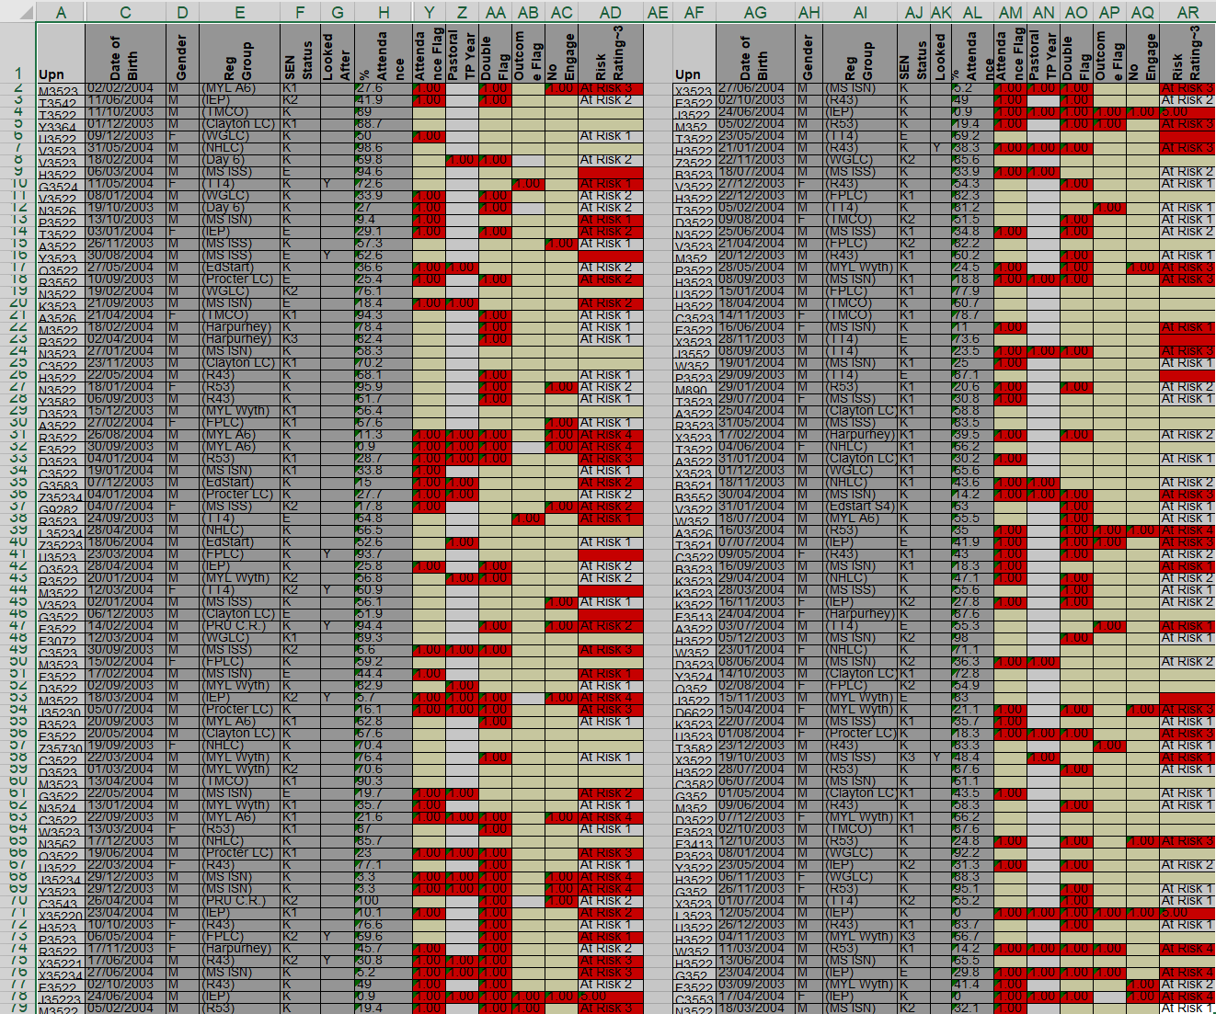

## Appendix D

## AP Evaluations

**Music Stuff Post 16 Interim Report**

September 2020

**Our work through the summer, progress made and our current position:**

Throughout the summer we maintained a table (Appendix 1: Post 16 NEET Risk Overview) that included a weekly RAG rating for each year 11 school leaver. The RAG rating reflected their NEET risk.

The risk was assessed based off our continued contact with each pupil to track and support their progress, this in turn informed our RAG rating.

Alongside the table (Appendix 1: Post 16 NEET Risk Overview) we maintained comprehensive contact logs of all contact/attempted contacts throughout the summer.

We liaised with different professionals and external agencies to support with coordinating our efforts to support our year 11 school leavers. A record of this contact was also maintained on our contact logs.

In summary:

* We made 280 entries to contact logs throughout the summer.
* We had direct contact with pupils and their parents/carers
* We tracked and monitored home visits carried out by our staff and those from external agencies
* We developed and maintained close partnership work with external agencies including colleges, training providers, youth support agencies and career connect.
* Tracked and weekly RAG rated NEET Risk Level - Progress has been clearly reflected across the table (Appendix 1: Post 16 NEET Risk Overview) for the most part
* We have a full picture of where our pupils have been at throughout the summer
* We have seen an improvement in our RAG Rating through the summer for 16 pupils
* We have supported 11 pupils to maintain a Green on our RAG rating
* 2 pupils remained in their Amber position. Both were in line for an improvement to Green, unfortunately one is abroad, presumably for a holiday and one has moved away with no forwarding address. Both are being followed up and we anticipate both will want to start at college still.
* There has been a decline with 3 pupils in their RAG rating. One is due to their planned employment being put on hold because of covid-19 restrictions. Another is because of a mix-up with age restrictions on the building site he was meant to be working on.
* The final one is due to a late change of heart – pupil decided he no longer wanted to go to college and instead wanted something work based.

**Challenges we faced**

* After and during us providing a high level of support through various platform for pupils; we had some agreeing to engage with courses and presenting as keen and motivated. Unfortunately, they would then not follow up on final steps and would cease contact for periods of time.
* 2 pupils from the same household from traveller families and seemingly wanting to keep their work lives private.
* One pupil was reported to have moved to a new house with no forwarding address whatsoever so work in tracking that pupil was set in motion.
* Uncooperative family members and no direct line to contact pupils/not home during home visits.
* One pupil scheduled to start college but then appears to have gone abroad with no further contact. This is being chased daily and further investigations underway.

**Our work moving forward**

Because we have managed to maintain accurate tracking of pupils, we have clear oversight of which pupils are still NEET, which are potentially ‘at risk’ and then those other pupils that seem secure in their current positions.

Going forward there are plans in place to engage with each of our pupils that are NEET. Callan Glean is coordinating the multi-agency effort.

Additionally, we will be maintaining contact with those ‘at risk’ and currently secure pupils to prevent anyone slipping through the cracks.

We will be carrying out/tracking home visits and making regular attempts to contact pupils – maintaining detailed records and strategically targeting efforts according to need.

There are plans in place for 6 of our NEET pupils on 22nd September 2020 to have an initial look around the Skills Construction Centre in Clayton. The visit will be supported by Colette Torkington and Nicole Daswon from Career Connect along with Julia Richardson from MSPRU. Callan Glean will make contact with each pupil to encourage their engagement.

The Skills Construction Centre offer Entry and Level 1 Awards/Certificates/Diplomas in a variety of construction craft trades. Big selling point is they will pay for the CSCS card and help them prepare for it and won’t put them in for it until they know they are ready for it. They will help the young people achieve the qualifications and support them with completing the workbooks, acting as a scribe/reader etc if required after they have done practical activities. Students are required to wear masks during the visit which will be provided by Nicole.

As always, we will keep MSPRU updated on all progress.

Completed by:

Daniel McCann

Deputy Head (Pastoral)

**Post 16 Transition Report Manchester Secondary PRU/Manchester College**

**July-Dec 2020**

**Objectives July-Sept**

* To monitor the transition of Manchester Secondary PRU Year 11 learners through a clear transition process from school into a post-16 study programme.
* To provide a single point of contact for learners, teachers support staff and external agencies.
* To provide on-site, needs-based interventions and off-site outreach to support learners to successfully sustain transition into post-16 provision.

**Activity July-Sept**

Establish Process

* Designate Lead Co-ordinator
* Begin recruitment process for Youth Coach
* Co-ordinating with key (named) staff from:

Careers Connect, CAWS, Student Experience, Transition Team, School Liaison, Core PRU Centre Managers, Transition link manager MSPRU

Identify learners

* 151 students on list of school leavers shared by Manchester Secondary PRU.
* TMC School Liaison Team identified 101 school leavers who had expressed an interest in attending a course at TMC during the previous year. Some had TMC as a second choice.
* Training was delivered to Manchester Secondary PRU Centre staff around TMC online application and enrolment process.
* During this process a further 20 learners decided to attend other colleges, training providers, gained employment or refused support to apply.
* 35 of the 101 learners were identified as having EHCP or Learning Support needs and were managed through the college ‘Transition Team’ with a dedicated SEN&D Specialist Transition Officer.

Keep Warm

* [TMC Couch to College](https://www.tmc.ac.uk/news/get-ready-couch-college) school leavers were invited to attend TMC digital sessions during the first three weeks of July as a way of transitioning from school to their future learning while lockdown restrictions were in place.
* 97 school leavers were case loaded and contacted by a single point of contact from TMC to support with online application and early enrolment during July and August.

Manage Enrolment Process

* Single point of contact arranged on-site face to face orientation meeting with 57 school leavers across 6 sites.
* 35 school leavers completed enrolment during this initial process
* Further appointments were made for those that didn’t attend. In total 59 school leavers completed enrolments before September.

**Objectives Sept-Dec**

* To provide on-site, needs-based interventions and off-site outreach to support learners to successfully sustain transition into post-16 provision.
* To monitor effectiveness of engagement in post-16 study programme throughout Autumn term.

**Activity Sept-Dec**

Non-Starters

3 school leavers never attended any sessions

* Historic non-attender Social work contact, Welfare check by GMP, referred to Career Connect.
* Moved out of area for own safety
* Went to another college where friends were

**Autumn Term 1 Sept-Oct**

8 students withdrawn in Autumn term 1

* 3 withdrawn for poor attendance- Supported by achievement tutors, student experience team as well as single point of contact. Students invited to re-enrol in January if circumstances change. Referred to Career Connect.
* 1 student left because of terminal illness within the family. Supported by single point of contact and Careers Connect.
* 2 students with SEN needs were unable to maintain behaviour for learning and attendance dropped. SEN Transition Team, Student Experience and Achievement Tutor involvement. Referral made to college Go Learn team who are trying to re-engage.
* 1 student transferred course because he didn’t like it. He didn’t settle with PEERS and was absent with bouts of self-isolation throughout September and October. Career Connect and Student Experience team working to re-engage him for a January start.
* 1 Student moved out of the country.

**Autumn Term 2 Oct-Dec**

7 students withdrawn in Autumn term 2

* 2 students with SEN needs were unable to maintain behaviour for learning and attendance dropped. SEN Transition Team, Student Experience and Achievement Tutor involvement. Referral made to college Go Learn Team and Career Connect who are trying to re-engage.
* 1 student withdrawn for violent behaviour. Offer made of place on different campus but declined. Has gone to training provider via Career Connect.
* 1 student left to take up the offer of an apprenticeship.
* 2 students withdrawn for poor attendance. Supported by achievement tutors, student experience team as well as single point of contact. Referred to Careers Connect.
* 1 student has moved away.

**Impact**

Out of the 59 students who enrolled at TMC in September 2020, 41 students are still with us.

39 students have had interventions of some sort with Student Experience Team or Achievement Tutor. Single point of contact has contacted learners/parents on average every two to three weeks and has liaised with Tutors/Student Experience/Managers weekly.

Weekly panel meetings have been held with Career Connect and MSPRU Transition Lead.

Fortnightly panel meetings have been held with SEN Transition Team Specialist

**Resource costs**

|  |  |
| --- | --- |
| Backfill of 0.5 days per week management time Aug-Dec (20 weeks) | £2,519 |
| Backfill of 2.5 days per week Project Coordinator/Single point of contact (20 weeks) | £10,160 |
| Backfill of 2 day per week x3 YCWS Centre staff July-Sept (8 weeks) | £6,144 |
| Staff Travel (6 sites) | £275 |
| Equipment (laptop/Mobile Phone) Estimate | £800 |
|  | **£19,898** |
|  |  |

MYL Summary of Transitions Work

As part of our work to support students to transition successfully to a post-16 destination, we planned and delivered a tiered approach to the Year 11’s of 2019-20 of extra support. This work started in June 2020 as lockdown was easing, continued over summer 2020, and through the autumn term up until January 2021.

We undertook an analysis of each of our cohort of 17 Year 11’s to determine a likelihood of NEET based on factors such as attendance, attainment, negative behaviour in the community, agencies involved etc. We decided that our own staff team were best placed to do most of the work, as they already have a trusted relationship with the young person and their family.

Tiers of need

LOW - All 17 young people at least accessed our low tier of support. This involved keep in touch calls, from a member of staff that they trust, to check on how they were settling in and to give IAG or signpost where necessary. If they are settled on to a course (EET), the calls reduced to approximately once per month. All young people engaged with this level of support except for one (BC) who engaged until he temporarily left the country for Romania, however he did re-engage on his return and was last contacted in January 2021.

MEDIUM – Some of our students who were undecided or unsettled on a course were invited in for a dedicated 1:1 appointment on Friday afternoons or in some cases after 3pm during the week. Out of the 17, eight accessed face to face or telephone sessions regularly over summer, and as they enrolled on to courses this reduced to five who accessed further support in autumn term. The eight students received approximately 6-8 hours of additional support.

HIGH – If the young person is uncontactable and we believe they may be NEET and isn’t responding to our regular contact, then we were able to signpost them to other agencies for help, including our own Youth Engagement team. Of the 17 students two were identified, who both received extra contact but ended up moving out of area. Details were passed on to Career Connect after that to signpost them further.

Summary

Overall, the project went well and students were all able to access a higher level of transitional support than had been offered before. Some students are still in touch as per their request as they feel uncertain about their course or have had personal problems, and feel they trust us to talk to. All 17 students received at least three hours of extra support in the lower tier by way of keep in touch phone calls, and the eight who access up to eight additional hours of support have been listed in the attached transitions record.

Outcomes for each young person were recorded, reviewed and support was delivered and made available accordingly. In the instance where a young person did not take up the 1:1 appointments the support was outlined clearly and parents and carers also knew where to go for support. Career Connect were also contacted regularly to provide wrap around support and transparency of information for the FE intuitions.